Consuelo Contreras
Week 4
7/6/2015
This was a tough week for me. Many times in life when we are living so fast that time we don’t appreciate the important little things in life. On Tuesday, I was not feeling well. I thought about calling my office, but I end up not doing it because I know we have a lot of work to do before the HEP/CAMP directors meeting. I got ready and headed to work. As soon as I got to my office I realized I didn’t have my ID. I always leave early and I was happy I still had twenty minutes to come back to GW and get my ID. I walked back to the metro and took the orange line to Foggy Bottom. I exited out quietly from the metro station and ran to my dorm. Punctuality is very important to me and my purpose since I was here was to don’t be late for work. In less than five minutes I was back in the metro trying to get back to work on time. The blue metro stops and I noticed it was extremely crowded. I didn’t want to take it, but I didn’t want to be late to work either so I ran inside the metro. Once in the metro I realized I couldn’t even breathe, much less move. In the next stop most people got out and there was a space for me to sit. I sat and I place my bag in my lap, I was about to open my bag to grab my phone and I realized my bag was open. I started looking inside the bag for my phone and I couldn’t find it. I started freaking out because I know someone had stolen it. I missed my stop because I was looking for my phone and I got out of the metro in the next stop which was Capital South. I ran to the little station in the metro where security is and told them what happened. They called the police and asked me to wait for the officer to come and report my stolen phone. Unfortunately, when the police officer came and I told him what happened he said that there was nothing that he could do because I didn’t know how the person looks like. Very sad and hopeless I walked to my office. As soon as I got there I told everybody what happened and they were so supportive and everybody was trying to help me. My supervisor Tara is so wise and smart, she gave me a link where I could report what happened. I also filed a report to the metro station website. I know it was just a phone and something material, but I bought it with my own money. I worked for it and it’s hard to believe that people would do something like that. In the other hand I am grateful because I learned how to file a formal police report as well as a report to a corporation. But what was more important for me was to see how much the members of the Office of Migrant Education care about me. I see them as a family and I know it’s been such a short period of time to say this, but I have learn so much from each of them and I feel nothing but gratitude towards them. Thank you for your support that day Lisa Ramirez, Tara, Edward, Preeti, Celeste, Pat, Nate, Lisa Guillete and Karla.
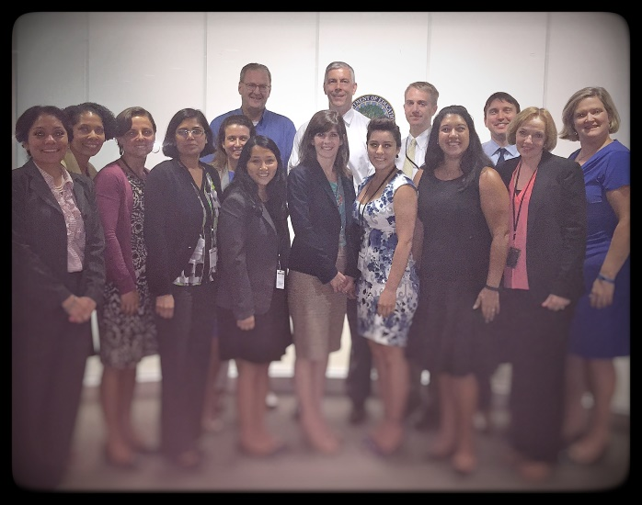
Work has been amazing like I mentioned. I am working really closely with data from HEP/CAMP. Edward and Preeti took the time to teach me how to organize all this data. Edward has been so patient and taken the time to explain the data and Preeti has been teaching me how to organize this data. I am gaining so much experience with Excel. As soon as I go back to school I want to take some class about data and how to analyze because I think it is a very helpful and useful skill to have.
I also got to meet Arne Duncan, the Secretary of Education. It was a very inspiring moment because Araceli, the other intern at OME, and I had the opportunity to ask him questions. I was speechless when I saw he walked into the room where we were having our meeting. One thing I have learned about D.C. is that everything is possible, you will have many opportunities to meet important people and you need to be prepared and take advantage. I know America is changing every day and I hope one day all those migrant students out there will have an easier path to get college paid for.
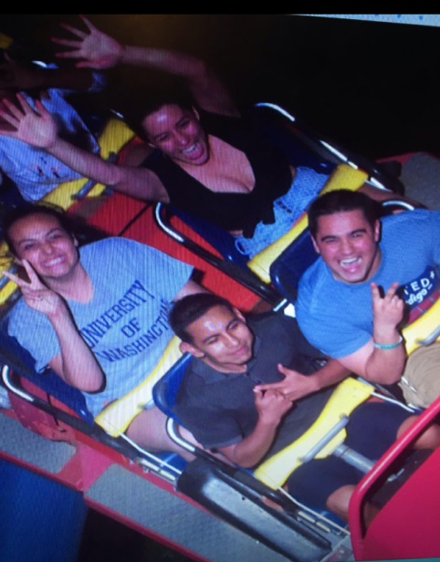
Even though I had a tough week for many different reasons my weekend was amazing. On Friday I got to go to Six Flags. Oh my! My first time on a huge roller coaster was amazing. The other CAMP interns went as well. We planned to ride all the roller coasters and we did. Our favorite was superman. We rode that one two times and it is very scary, but exciting at the same time. We spent our whole day there. We ate Chinese food and a flake cake. They also had fireworks which were extremely beautiful. Unfortunately, our phones didn’t have enough battery and we didn’t get to take pictures. Coming back was the difficult thing because the bus never came, after waiting for the bus for more than an hour we got a taxi and it took us to the metro station. From there we took the metro home. I was very happy that night because I realized that roller coasters are like life. Many times we are up/ high in our lives, and we are so scared to fall down, but once we are down we realized that is not too bad and that we can always go up again. Also, life is excited and fast like a roller coaster and we need to keep our eyes open to appreciate everything. We ride a roller coaster every day of our lives and it’s OK to be scared, because we can overcome those fears in life.
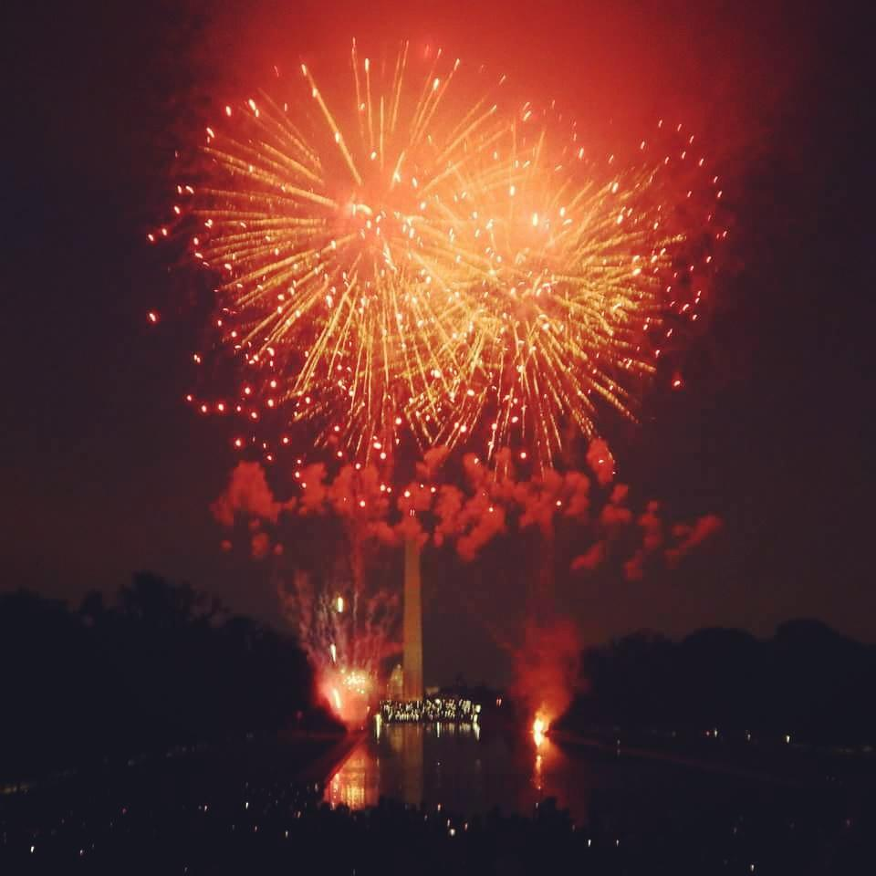
I have never celebrated at 4th of July since I came to America almost 4 years ago. The past 4th of July I was working and my 3rd one I went to Mexico to see my family. Spending 4th of July in DC was amazing. I felt very patriotic, something I never felt before. Early in the day I went to see the parade and it was exciting to see different people representing their cultures and who they are in America. Later that day, I went to the mall where I got to spend the afternoon with the CHCI interns as well as CAMP interns. It had an amazing time talking about our life and experiences. The moment that we all waited was finally there, around 9:10 p.m. the fireworks show started. I was amazed; there are no words to explain how beautiful the show was. It was inspiring, exciting and a very happy moment to all the people that was there watching them. We united as one. Our nationally, skin color, race, sex and language didn’t matter in that moment. We were one nation a nation that loves America deeply. After the fireworks I went dancing Salsa with Magali and other CHCH interns. It was really fun.
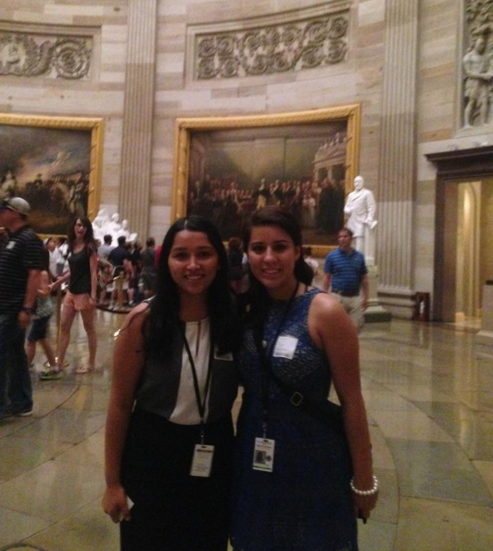
On Sunday, I went to the Arlington Cemetery. I got to see the grave of President Kennedy and his family. This was really sad for me. I just keep thinking that all these people lived once and now they are not here with us. But this is life and we have to live it to the fullest.
Also, I got a tour the Capitol Hill. It is beautiful inside and there’s so much history within those walls. I was honor to have the privilege to go inside and appreciate all the statues, paintings, and the beautiful architecture. My favorite part was the old Supreme Court room.
I only have four weeks left. I am excited because these upcoming weeks because will be unforgettable and I am going to take advantage of every single moment. Thank you to the HEP/CAMP associating for giving me this life changing experience. I will never be the same.

